# VISVESVARAYA TECHNOLOGICAL UNIVERSITY

## BELAGAVI – 590018, Karnataka INTERNSHIP REPORT

#### ON

***Submitted in partial fulfilment for the award of degree(18EEI85)***

**STOCKPORT | PREDICTIVE SENTIMENT ANALYSIS USING MACHINE LEARNING**

## BACHELOR OF ENGINEERING IN

## Electrical and Electronics Engineering

## Submitted By:

## UMASHREE R K (1MV20EE069)



Conducted at

Varcons Technologies Pvt Ltd

# 

**Department of Electrical & Electronics Engineering**

**Sir M VISVESVARAYA INSTITUTE OF TECHNOLOGY**

(Approved by AICTE New Delhi, Affiliated to VTU, Belagavi, ISO 9001:2008 Certified)

Off International Airport Road, Krishnadevaraya Nagar, Bengaluru – 562157

**2023 – 2024**

# 

**CERTIFICATE**

This is to certify that the Internship titled **“STOCKPORT | PREDICTIVE SENTIMENT ANALYSIS”** carried out by **Miss UMASHREE R K,** a bonafide student of Sir M. Visvesvaraya Institute of Technology, in partial fulfillment for the award of **Bachelor of Engineering**, in **Electrical and Electronics Engineering** under Visvesvaraya Technological University, Belagavi, during the year 2023-2024. It is certified that all corrections/suggestions indicated have been incorporated in the report.

The project report has been approved as it satisfies the academic requirements in respect of Internship prescribed for the course Internship (18EEI85)

#### Signature of Guide Signature of HOD Signature of Principal

Ms. Bindiya TyagiDr. Suresh H.L Prof.Rakesh S G

**External Viva:**

Name of the Examiner Signature with Date

1)

2)

# DECLARATION

I, **UMASHREE R K** final year student of **Electrical and Electronics Engineering, Sir M. Visvesvaraya Institute of Technology**, declare that the Internship has been successfully completed, in **VARCONS TECHNOLOGIES PVT LTD**. This report is submitted in partial fulfillment of the requirements for award of Bachelor Degree in Electrical and Electronics Engineering, during the academic year 2023-2024.

Date : 20/09/2023 :

Place : Bengaluru

USN : 1MV20EE069

NAME :UMASHREE R K

**OFFER LETTER**

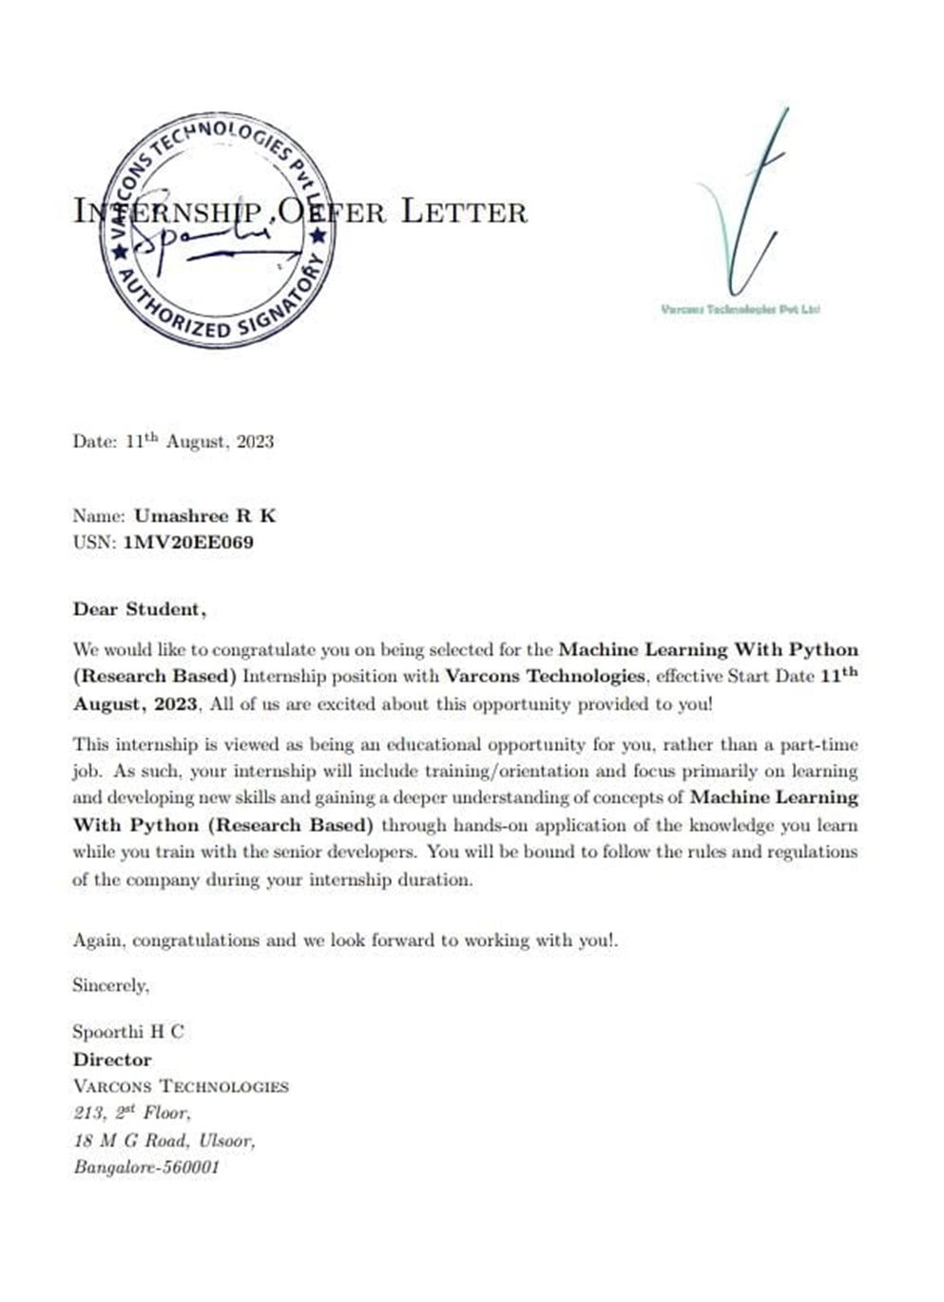

# ACKNOWLEDGEMENT

This Internship is a result of accumulated guidance, direction and support of several important persons. We take this opportunity to express our gratitude to all who have helped us to complete the Internship.

We express our sincere thanks to our Principal, for providing us adequate facilities to undertake this Internship.

We would like to thank our Head of Dept – branch code, for providing us an opportunity to carry out Internship and for his valuable guidance and support.

We would like to thank our (Lab assistant name) Software Services for guiding us during the period of internship.

We express our deep and profound gratitude to our guide, Guide name, Assistant/Associate Prof, for her keen interest and encouragement at every step in completing the Internship.

We would like to thank all the faculty members of our department for the support extended during the course of Internship.

We would like to thank the non-teaching members of our dept, forhelping us during the Internship.

Last but not the least, we would like to thank our parents and friends without whose constant help, the completion of Internship would have not been possible.

**NAME: UMASHREE R K**

**USN: 1MV20EE069**

# ABSTRACT

Sentiment analysis and opinion mining have been acquiring a crucial role in both commercial

and research applications because of their possible applicability to several different fields.

Therefore a large number of companies have included the analysis of opinions and sentiments of

customers as part of their mission. One of the most interesting applications of these approaches

involves the automatic analysis of social network messages, on the basis of the feelings and

emotions conveyed. This chapter aims to relate the most recent state-of-the-art sentiment-based

techniques and tools to the affective characterization that may be inferred from social networks.

The main result consists of a review of the most interesting methods employed to compare and

classify messages on social media platforms and a description of advanced tools in this area.

Opinion mining has been ordinarily connected with the examination of a content string to decide

if a corpus is of a negative or positive sentiment. As of late, opinion mining has been stretched

out to address issues, for example, recognizing objective from subjective suggestions and

deciding the sources and points of various suppositions communicated in text informational

collections, for example, tweets, message board, web blogs, movie reviews, and news.

Sentiment analysis and opinion mining have been acquiring a crucial role in both commercial and research applications because of their possible applicability to several different fields. Therefore a large number of companies have included the analysis of opinions and sentiments of customers as part of their mission. One of the most interesting applications of these approaches involves the automatic analysis of social network messages, on the basis of the feelings and emotions conveyed. This chapter aims to relate the most recent state-of-the-art sentiment-based techniques and tools to the affective characterization that may be inferred from social networks. The main result consists of a review of the most interesting methods employed to compare and classify messages on social media platforms and a description of advanced tools in this area. Opinion mining has been ordinarily connected with the examination of a content string to decide if a corpus is of a negative or positive sentiment. As of late, opinion mining has been stretched out to address issues, for example, recognizing objective from subjective suggestions and deciding the sources and points of various suppositions communicated in text informational collections, for example, tweets, message board, web blogs, movie reviews, and news. Companies can use sentiment extremity and opinion point acknowledgment to pick up a more profound comprehension and the general extent of estimations. These experiences can progress focused insight, enhance client benefit, accomplish better brand picture, and upgrade competitiveness. In the aircraft service industry, it is hard to gather information about clients’ input by polls, yet Twitter gives a sound information source to them to do client opinion examination. This paper presents positive, negative sentiment, and their correlation about customer tweets. BIRCH clustering and Association rule mining have been used in this chapter to get inside the dataset and retrieve hidden knowledge.

# Table of Contents

|  |  |  |
| --- | --- | --- |
| **Sl no** | **Description** | **Page no** |
| 1 | Company Profile | 8-9 |
| 2 | About the Company | 10-11 |
| [3](https://1.bp.blogspot.com/-dODuK8N5h1Q/Wlnyb3V9HFI/AAAAAAAACL4/WxQtCJ1pM5wccDABg4wIrTBUB0vlikXQQCLcBGAs/s1600/poly1.jpg) | Introduction | 12-13 |
| [4](https://1.bp.blogspot.com/-dODuK8N5h1Q/Wlnyb3V9HFI/AAAAAAAACL4/WxQtCJ1pM5wccDABg4wIrTBUB0vlikXQQCLcBGAs/s1600/poly1.jpg) | System Analysis | 14-15 |
| [5](https://1.bp.blogspot.com/-dODuK8N5h1Q/Wlnyb3V9HFI/AAAAAAAACL4/WxQtCJ1pM5wccDABg4wIrTBUB0vlikXQQCLcBGAs/s1600/poly1.jpg) | Requirement Analysis | 16-17 |
| 6 | Design [Analysis](https://4.bp.blogspot.com/-IOOxgPaXMVc/Wlj3LWvcnjI/AAAAAAAACKE/UeTFYvAxDmUDel5UBjdifeWaApB3-dXVgCLcBGAs/s1600/img1.jpg) | 18-19 |
| 7 | [Implementation](https://4.bp.blogspot.com/-IOOxgPaXMVc/Wlj3LWvcnjI/AAAAAAAACKE/UeTFYvAxDmUDel5UBjdifeWaApB3-dXVgCLcBGAs/s1600/img1.jpg) | 20-21 |
| 8 | Snapshots | 22-24 |
| 9 | Conclusion | 25-26 |
| 10 | References | 27 |

[**CHAPTER**](https://1.bp.blogspot.com/-dODuK8N5h1Q/Wlnyb3V9HFI/AAAAAAAACL4/WxQtCJ1pM5wccDABg4wIrTBUB0vlikXQQCLcBGAs/s1600/poly1.jpg) **1** **COMPANY PROFILE**

# COMPANY PROFILE

## A Brief History of Company

Company, was incorporated with a goal ”To provide high quality and optimal Technological Solutions to business requirements of our clients”. Every business is a different and has a unique business model and so are the technological requirements. They understand this and hence the solutions provided to these requirements are different as well. They focus on clients requirements and provide them with tailor made technological solutions. They also understand that Reach of their Product to its targeted market or the automation of the existing process into e-client and simple process are the key features that our clients desire from Technological Solution they are looking for and these are the features that we focus on while designing the solutions for their clients.

Company is a Technology Organization providing solutions for all web design and development, MYSQL, PYTHON Programming, HTML, CSS, ASP.NET and LINQ. Meeting the ever increasing automation requirements, Sarvamoola Software Services. specialize in ERP, Connectivity, SEO Services, Conference Management, effective web promotion and tailor-made software products, designing solutions best suiting clients requirements.

we strive to be the front runner in creativity and innovation in software development through their well-researched expertise and establish it as an out of the box software development company in Bangalore, India. As a software development company, they translate this software development expertise into value for their customers through their professional solutions.

They understand that the best desired output can be achieved only by understanding the clients demand better. At our Company we work with them clients and help them to defiine their exact solution requirement. Sometimes even they wonder that they have completely redefined their solution or new application requirement during the brainstorming session, and here they position themselves as an IT solutions consulting group comprising of high caliber consultants.

They believe that Technology when used properly can help any business to scale and achieve new heights of success. It helps Improve its efficiency, profitability, reliability; to put it in one sentence ” Technology helps you to Delight your Customers” and that is what we want to achieve.

# [CHAPTER](https://1.bp.blogspot.com/-dODuK8N5h1Q/Wlnyb3V9HFI/AAAAAAAACL4/WxQtCJ1pM5wccDABg4wIrTBUB0vlikXQQCLcBGAs/s1600/poly1.jpg) 2 ABOUT THE COMPANY

1. **ABOUT THE COMPANY**

We are a Technology Organization providing solutions for all web design and development, Researching and Publishing Papers to ensure the quality of most used ML Models, MYSQL, PYTHON Programming, HTML, CSS, ASP.NET and LINQ. Meeting the ever increasing automation requirements, Compsoft Technologies specialize in ERP, Connectivity, SEO Services, Conference Management, effective web promotion and tailor-made software products, designing solutions best suiting clients requirements. The organization where they have a right mix of professionals as a stakeholders to help us serve our clients with best of our capability and with at par industry standards. They have young, enthusiastic, passionate and creative Professionals to develop technological innovations in the field of Mobile technologies, Web applications as well as Business and Enterprise solution. Motto of our organization is to “Collaborate with our clients to provide them with best Technological solution hence creating Good Present and Better Future for our client which will bring a cascading a positive effect in their business shape as well”. Providing a Complete suite of technical solutions is not just our tag line, it is Our Vision for Our Clients and for Us, We strive hard to achieve it.

## Services provided by Varcons Technologies.

* Core Java and Advanced Java
* Research and Development/Improvise of ML Models
* Web services and development
* Dot Net Framework
* Python
* Selenium Testing
* Conference / Event Management Service
* Academic Project Guidance
* On The Job Training
* Software Training

# [CHAPTER](https://1.bp.blogspot.com/-dODuK8N5h1Q/Wlnyb3V9HFI/AAAAAAAACL4/WxQtCJ1pM5wccDABg4wIrTBUB0vlikXQQCLcBGAs/s1600/poly1.jpg) 3 INTRODUCTION

1. **INTRODUCTION**

## Introduction to ML

Machine Learning (ML) is a subfield of artificial intelligence (AI) that focuses on developing algorithms and models that enable computers to learn and make predictions or decisions based on data. It is a transformative technology that has gained immense popularity and applications across various industries in recent years.

At its core, ML is about creating algorithms that can automatically learn from data and improve their performance over time without being explicitly programmed. This is in contrast to traditional software development, where programmers write explicit instructions to perform tasks. In ML, the system learns patterns, relationships, and insights directly from the data.

## Problem Statement

## "Developing a Machine Learning-Based STOCKPORT | PREDICTIVE SENTIMENT ANALYSIS "

This is an innovative System for visually impaired people and acts as a voice assistant for them. This system is used to help the visually impaired to have access to the most important features of the phone enhancing the quality of the system making use of different custom layouts and using speech to text.

The System has custom messaging feature with inbox and sent items, call log and dialer, notes and battery level checking and reminder. All actions performed by the user the system speaks out and helps the user to know his current position. The System helps the user to also read the contents of the message along with the sender and the date and time, in whole everything. The system also allows the user to note few things with its custom note pad

.The System speaks out the dialer number pressed and called notification also. The System in all is a voice assistant for whatever action the user has performed though a custom app while taking the data from the default application. The custom app doesn’t save any data it is dependent on the phone.

# [CHAPTER](https://1.bp.blogspot.com/-dODuK8N5h1Q/Wlnyb3V9HFI/AAAAAAAACL4/WxQtCJ1pM5wccDABg4wIrTBUB0vlikXQQCLcBGAs/s1600/poly1.jpg) 4 SYSTEM ANALYSIS

**4. SYSTEM ANALYSIS**

**\*Existing System:\***

The EXISTING SYSTEM ANALYSIS began with public ratification of the study work plan, and the identification of transportation issues and public attitudes. Existing transportation system characteristics were then reviewed based on available information, plus new data obtained from three major surveys.**.**

**\*Proposed System:\***

The assembly of an operational group of computer programs that will perform, without modification, a significant portion of the functional requirements contained in this RFP. The Proposed System should include system interfaces and conversion tools as well as Contractor supplied or recommended third party software products required to properly design, develop, test, train, implement, interface, tune, and operate the Proposed Solution. The Proposed System should include Document Management, Workflow, a Rules Engine, and Customer Relationship Management functionality.

**\*Objective of the System:\***

Project objectives are what you plan to achieve by the end of your project. This might include deliverables and assets, or more intangible objectives like increasing productivity or motivation. Your project objectives should be attainable, time-bound, specific goals you can measure at the end of your project helping them reach their desired destinations.

# [CHAPTER](https://1.bp.blogspot.com/-dODuK8N5h1Q/Wlnyb3V9HFI/AAAAAAAACL4/WxQtCJ1pM5wccDABg4wIrTBUB0vlikXQQCLcBGAs/s1600/poly1.jpg) 5 REQUIREMENT ANALYSIS

**5. REQUIREMENT ANALYSIS**

## Hardware Requirement Specification

1. Screen: 5 inch
2. Ram: 6GB
3. Rom : 1Gb
4. Processor: 11th Gen Intel(R) Core(TM) i5-11320H @3.20GHz 2.50 GHz

## Software Requirement Specification

1. Opencv
2. -contrib-python
3. SpeechRecognition
4. pyttsx3
5. google-cloud-
6. speech nltk
7. dialogflow
8. pyAudio wave
9. google-cloud-vision

# [CHAPTER](https://1.bp.blogspot.com/-dODuK8N5h1Q/Wlnyb3V9HFI/AAAAAAAACL4/WxQtCJ1pM5wccDABg4wIrTBUB0vlikXQQCLcBGAs/s1600/poly1.jpg) 6 DESIGN ANALYSIS

1. **DESIGN & ANALYSIS**

Design and Analysis of a Stockport | predictive sentiment analysis using Machine Learning

The system comprises a modular client server distributed architecture. The system consists of the main menu which first runs on the startup of the software and the website modules. The client communicates with the server and back with the use of REST APIs,thus the website modules are not local to the client. Throughout the system, the user communicates with the software via speech-to-text interface. The Google library of speech-to-text (Speech Recognition) for Python is used for this purpose. For communicating the system’s output to the user as well as for confirming the user input, the recognized input is played back to the user using the Python text-to-speech library (pytssx3). The modules are written in Python and make use of Selenium for automation of the respective module and Beautiful Soup for scraping the contents of the web page. The “Script” component of each module consists of the customized code that entails the features of the website contained in the module. For instance, the Wikipedia module consists of a Question and Answer and Summary feature along with the traditional feature of reading out the entire article. The former is implemented by training a BERT model on the Stanford Question Answering Dataset (SQuaD). The APIs that hold the system together are written in Flask. The software is operating system independent to support hassle free application and usage of the system.

# [CHAPTE](https://1.bp.blogspot.com/-dODuK8N5h1Q/Wlnyb3V9HFI/AAAAAAAACL4/WxQtCJ1pM5wccDABg4wIrTBUB0vlikXQQCLcBGAs/s1600/poly1.jpg)R 7 IMPLEMENTATION

1. **IMPLEMENTATION**

Implementation is the stage where the theoretical design is turned into a working system. The most crucial stage in achieving a new successful system and in giving confidence on the new system for the users that it will work efficiently and effectively.

The system can be implemented only after thorough testing is done and if it is found to work according to the specification. It involves careful planning, investigation of the current system and it constraints on implementation, design of methods to achieve the change over and an evaluation of change over methods a part from planning.

Two major tasks of preparing the implementation are education and training of the users and testing of the system. The more complex the system being implemented, the more involved will be the system analysis and design effort required just for implementation.

The implementation phase comprises of several activities. The required hardware and software acquisition is carried out. The system may require some software to be developed. For this, programs are written and tested. The user then changes over to his new fully tested system and the old system is discontinued.

## TESTING

The testing phase is an important part of software development. It is the Information zed system will help in automate process of finding errors and missing operations and also a complete verification to determine whether the objectives are met and the user requirements are satisfied. Software testing is carried out in three steps:

1. The first includes unit testing, where in each module is tested to provide its correctness, validity and also determine any missing operations and to verify whether the objectives have been met. Errors are noted down and corrected immediately.
2. Unit testing is the important and major part of the project. So errors are rectified easily in particular module and program clarity is increased. In this project entire system is divided into several modules and is developed individually. So unit testing is conducted to individual modules.
3. The second step includes Integration testing. It need not be the case, the software whose modules when run individually and showing perfect results, will also show perfect results when run as a whole.

# [CHAPTE](https://1.bp.blogspot.com/-dODuK8N5h1Q/Wlnyb3V9HFI/AAAAAAAACL4/WxQtCJ1pM5wccDABg4wIrTBUB0vlikXQQCLcBGAs/s1600/poly1.jpg)R 8 SNAPSHOTS

* 1. **SNAPSHOTS**

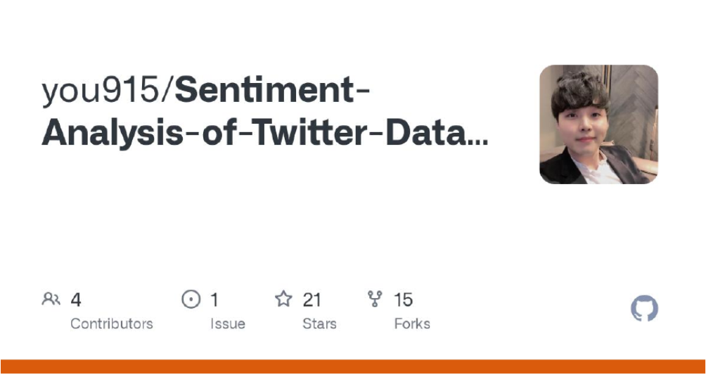

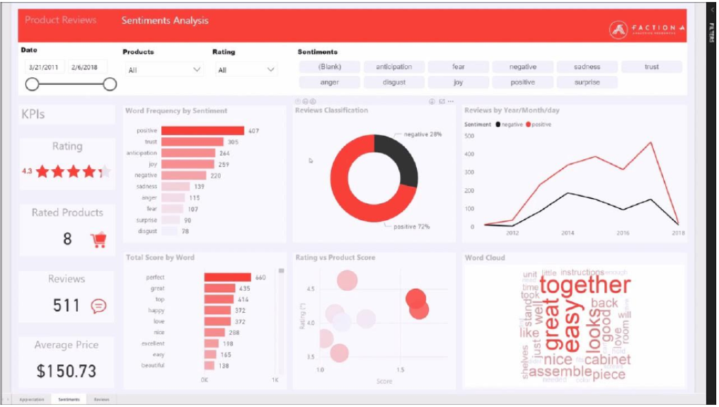

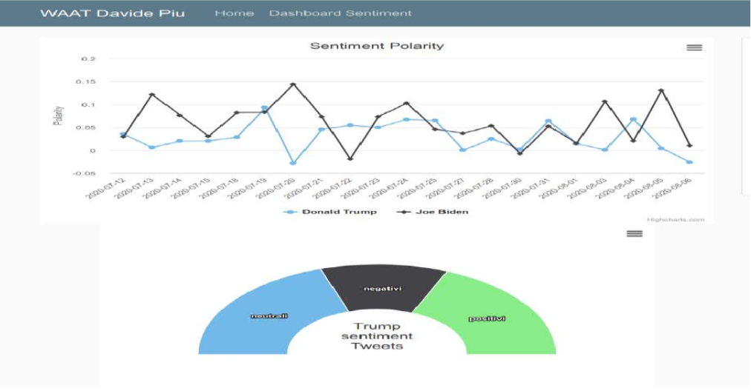

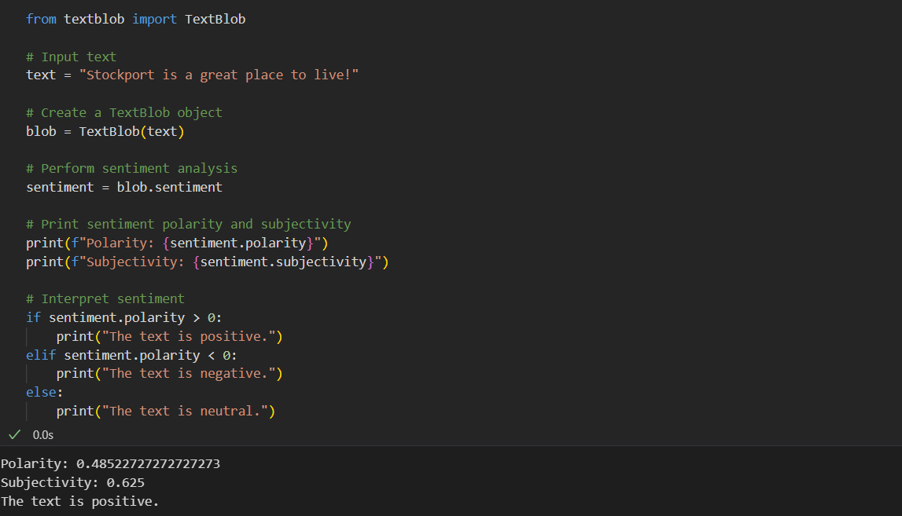

# [CHAPTE](https://1.bp.blogspot.com/-dODuK8N5h1Q/Wlnyb3V9HFI/AAAAAAAACL4/WxQtCJ1pM5wccDABg4wIrTBUB0vlikXQQCLcBGAs/s1600/poly1.jpg)R 9 CONCLUSION

* 1. **CONCLUSION**

The package was designed in such a way that future modifications can be done easily. The following conclusions can be deduced from the development of the project:

* Automation of the entire system improves the efficiency
* It provides a friendly graphical user interface which proves to be better when compared to the existing system.
* It gives appropriate access to the authorized users depending on their permissions.
* It effectively overcomes the delay in communications.
* Updating of information becomes so easier
* System security, data security and reliability are the striking features.
* The System has adequate scope for modification in future if it is necessary.

# REFERENCE

* <https://github.com/shirosaidev/stocksight.git>
* <https://github.com/shirosaidev/stocksight.gi>

**APPENDIX**

pip install textblob

from textblob import TextBlob

# Input text

text = "Stockport is a great place to live!"

# Create a TextBlob object

blob = TextBlob(text)

# Perform sentiment analysis

sentiment = blob.sentiment

# Print sentiment polarity and subjectivity

print(f"Polarity: {sentiment.polarity}")

print(f"Subjectivity: {sentiment.subjectivity}")

# Interpret sentiment

if sentiment.polarity > 0:

    print("The text is positive.")

elif sentiment.polarity < 0:

    print("The text is negative.")

else:

    print("The text is neutral.")

Polarity: 0.48522727272727273

Subjectivity: 0.625

The text is positive.